**Project Blindly**

Research Paper: **1**

Realtime object detection for visually challenged person NIT KURUKSHETRA

ORCID :0000-0002-7432-8506

Object recognition: Step by step: Recognizing $→$ Identifying $→$ Locating objects.

Recognition: $→$ Classification $→$ Detection.

**1.** Object Classify $→$ Feature extraction $→$ Localization $→$ Classification.

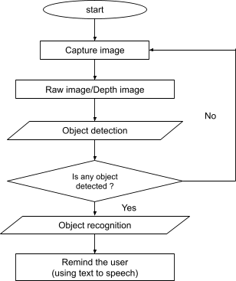Classification : Recognizes the class of objects (objects belongs to) A $°$ of confidence.

**2.**Detection $→$ Put bounding box in object in Picture.

Object Detection Algorithm: Region Based Object Detection (Accuracy)

E.g : YOLO (you only look once), MobileNet SSD

Regression Based Object Detection (Faster)

FPS (Frames Per Second), MAP (Mean Average Precision), and BFLOPs score on Various Datasets.

|  |  |  |  |  |  |
| --- | --- | --- | --- | --- | --- |
| **Model** | **Model Size** | **Dataset** | **FPS** | **mAP** | **BFLOPs** |
| YOLOv2 | **202.3M** | **DOTA** | **58.3** | **17.6** | **44.417** |
| YOLOv3 | **245.78M** | **DOTA** | **14.7** | **55.8** | **101.784** |
| YOLOv4 | **246.3M** | **MS COCO** | **18.5** | **55.4** | **128.459** |
| EfficientDet | **234.56M** | **MS COCO** | **6.5** | **55.1** | **40.223** |

Regression-based object detection algorithms divide the images into grids and provide 0 or 1 to each grid according to the object presence and absence, that is how regression-based algorithms detect objects in a single phase. As the name of regression-based algorithms also shows these algorithms work in single-phase like YOLO stands for You Only Look Once and SSD stands for Single Shot Detector